# Project Assignment

|  |  |  |  |  |
| --- | --- | --- | --- | --- |
| Treatment | Fruit Weight (g) | Fruit Diameter (cm) | Fruit Length (cm) | Yield per Plant (g) |
| T1 | 38.7±0.0577e | 3.3±0.0577f | 14.5±0.0577e | 220.7±0.0577c |
| T2 | 42.1±0.0577c | 3.9±0.0577b | 14.9±0.0577d | 198.7±0.0577e |
| T3 | 36.2±0.0577h | 3.5±0.0577e | 13.4±0.0577f | 186.9±0.0577g |
|  |  |  |  |  |
| T4 | 29.1±0.0577j | 2.8±0.0577h | 12.1±0.0577h | 120.6±0.0577k |
|  |  |  |  |  |
| T5 | 44.5±0.0577b | 3.7±0.0577cd | 15.6±0.0577b | 229.8±0.0577b |
|  |  |  |  |  |
| T6 | 37.5±0.0577g | 3.6±0.0577de | 15.4±0.0577c | 219.5±0.0577d |
|  |  |  |  |  |
| T7 | 47.8±0.0577a | 4.5±0.0577a | 16.4±0.0577a | 243.8±0.0577a |
|  |  |  |  |  |
| T8 | 39.8±0.0577d | 3.7±0.0577cd | 14.8±0.0577d | 195.8±0.0577f |
|  |  |  |  |  |
| T9 | 37.9±0.0577f | 3.8±0.0577bc | 15.4±0.0577c | 180.6±0.0577h |
|  |  |  |  |  |
| T10 | 32.5±0.0577i | 3.1±0.0577g | 13.5±0.0577f | 167.5±0.0577i |
|  |  |  |  |  |
| T11 | 27.8±0.0577k | 2.8±0.0577h | 12.7±0.0577g | 131.2±0.0577j |
|  |  |  |  |  |
| T12 | 26.1±0.0577l | 2.1±0.0577i | 11.8±0.0577i | 110.5±0.0577l |

**Morphological Attributes of Plants Under Different Treatments**

Table 1. The effects of different treatments on plant morphological characteristics, such as Fruit Weight (g), Fruit Diameter (cm), Fruit Length (cm), and Yield per Plant (g). The major differences between treatments are highlighted by listing each treatment together with the matching mean values ± standard error (SE). T1 is the control, which contains 500 ppm of saline and no salicylic acid; T2 contains 100 ppm of salicylic acid; T3, 500 ppm of saline; T4, 2500 ppm of saline; T5, 5000 ppm of saline; T6, 7500 ppm of saline; T7, 500 ppm of saline + 50 ppm of salicylic acid; T8, 2500 ppm of saline + 50 ppm of salicylic acid; T10, 7500 ppm of saline + 50 ppm of salicylic acid; T11, 2500 ppm of saline + 100 ppm of salicylic acid; and T12, 7500 ppm of saline + 100 ppm of salicylic acid. With statistical groups based on ANOVA results, each entry displays mean values ± standard error (SE) for Fruit Weight (g), Fruit Diameter (cm), Fruit Length (cm), and Yield per Plant

## Results & Discussion

The information in Table 1 makes it evident how different plant morphological characteristics—Fruit Weight, Fruit Diameter, Fruit Length, and Yield per Plant—respond to various treatments ranging from T1 to T12. Significantly, Treatment T7, which mixes 50 ppm salicylic acid with 500 ppm saline, performed better on every metric. The statistical grouping 'a' indicates that this treatment produced the highest Fruit Weight (47.8 g), Fruit Diameter (4.5 cm), Fruit Length (16.4 cm), and Yield per Plant (243.8 g), all of which were substantially higher than those in other treatments. In contrast, all of the following characteristics showed the lowest values for Treatment T12, which included the highest concentration of saline (7500 ppm) and 100 ppm salicylic acid: Fruit Weight (26.1 g), Fruit Diameter (2.1 cm), Fruit Length (11.8 cm), and Yield per Plant (110.5 g). This suggests that there was significant stress and negative effects on plant growth and productivity. A considerable statistical inferiority is indicated by the grouping 'l'. The effects of intermediate treatments varied; T1 (control) showed modest values but a larger yield than some treatments (such T2 and T6) with higher concentrations of saline or salicylic acid. It is noteworthy that the inclusion of salicylic acid at moderate saline concentrations (T5 and T7) appears to reduce the adverse effects of salinity, indicating a protective function of salicylic acid in response to salt stress. The observed trends indicate a complicated relationship between salicylic acid and saline concentrations, in which salicylic acid at particular levels might boost tolerance to saline stress, consequently enhancing overall plant structure and yield. These results support the idea that salicylic acid may significantly contribute to improving plant resistance to abiotic stressors, offering important information for farming methods in saline settings. In summary, the findings emphasize the significance of optimizing both salicylic acid and saline concentrations to enhance plant growth and yield, showcasing the potential for specific agronomic strategies to improve crop performance in stressful conditions.

### PCA, Dendogram & Correleation plot of the Treatment of the Project Dataset

## PCA- Biplot

Figure. 1. Biplot of Principal Component Analysis (PCA) illustrating the arrangement of treatments and reactions to traits. PC1 accounts for 36.9% of the variance, while PC2 explains 31.1%. Characteristics like flavonoids, GST, and anthocyanins are closely linked to treatments that have elevated levels of salicylic acid and salinity. On the other hand, yield-associated characteristics (such as fruit weight, yield per plant) correspond with treatments in less saline conditions. This visual representation emphasizes the effects of salinity and salicylic acid on plant characteristics, revealing unique clustering patterns across treatments.

## 2. Correlation (Pearson)

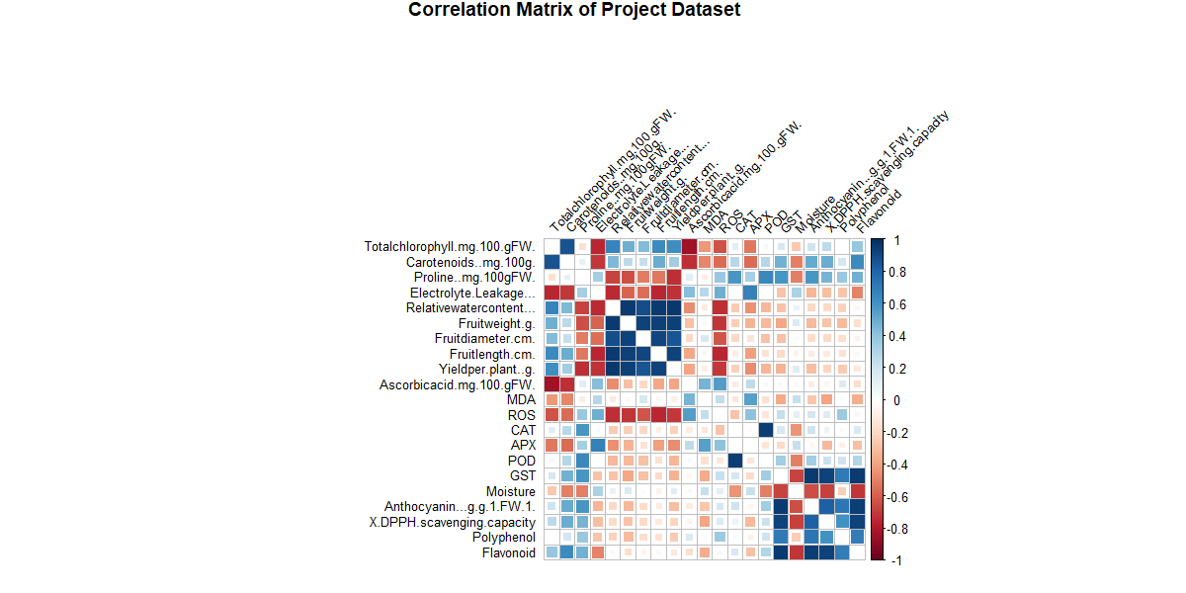

Figure.2. Matrix of correlations for the project dataset illustrating the connections between different plant characteristics across various treatments. Positive correlations are shown in blue hues, whereas negative correlations are represented in red hues, with more intense colors signifying greater correlation values. Significant clusters show strong positive associations among characteristics associated with fruit metrics (e.g., fruit weight, fruit diameter) and biochemical elements such as polyphenol and flavonoid. This matrix offers insights into the connections between physiological and biochemical traits affected by saline and salicylic acid treatments.

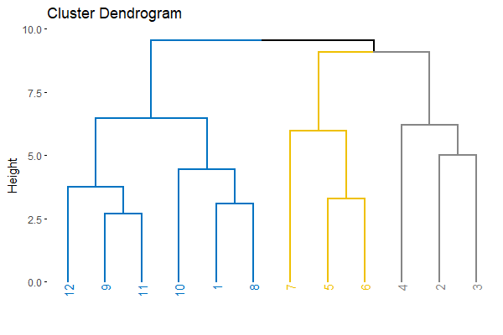3. Dendrogram

Figure 3. Dendrogram of treatments organized hierarchically according to physiological and biochemical characteristics. Treatments are categorized based on their similarities, with T12, T9, T11, T10, and T8 classified under high saline and/or salicylic acid circumstances, indicating comparable stress response patterns. Treatments with lower salinity (e.g., T3, T2, T4) create clear clusters, showing different reactions. This dendrogram offers insight into the effects of varying salinity levels and salicylic acid on clustering patterns, emphasizing the treatments that exhibit comparable stress adaptations.